**CIS 375 – Fall 2019 Term Project - BRAINS**



Use Case Specification Document

**5**

**Users Management**

**Version No. 1.1.1**

**Project Document Revision History**

|  |  |  |  |
| --- | --- | --- | --- |
| **VersionNumber** | **Date** | **Revision Author** | **Description of Revision** |
| 1.0.0 | 10/29/2019 | Cameron Labut | Creation of document |
| 1.0.1 | 10/29/2019 | Muaz Alhaidar | Updated Use case swimlane diagram |
| 1.0.2 | 10/31/2019 | Cameron Labut | Updated Use Case including swimlane for correctness, clarity, consistency, etc. |
| 1.1.0 | 12/14/2019 | Muaz Alhaidar | Changed swimlane, removed department features, and adjusted flows to match swimlane |
| 1.1.1 | 12/16/2019 | Muaz Alhaidar | Corrected typos and changed title from previous adjustment |

|  |
| --- |
| **Table of Contents** |

1. Introduction 4

2. Use Case Information 4

2.1 Actors 4

2.2 Use Case Interaction 4

3. Trigger 4

4. Pre-condition(s) 4

5. Post-condition(s) 5

5.1 User is added 5

5.2 User is removed 5

5.3 User is Modified 5

6. Use Case Swimlane (Activity) Diagram 5

7. Main/Basic Flow(s) of Events (Happy Path) 6

7.1 User is added 6

7.2 User is removed 6

7.3 User is Modified 6

8. Alternate/Exception Flow of Events 6

9. Assumptions/Business Rules including Non-Functional Requirements 6

10. Use Case Specification Review and Signoff 7

# Introduction

This use case is for the adding, removing and otherwise managing users within the system. Users are given credentials depending upon their rank/job within the company.

# Use Case Information

## Actors

An actor is someone or something (e.g. application system) outside the system or business that interacts with the application. For every Use Case, there must be at least one Main Actor and zero or more Secondary Actors. Actors should be a person, system, or time.

|  |  |  |
| --- | --- | --- |
| Actor Name | Role | Description |
| Database | Secondary | Stores all data and tasks performed the oversight team. |
| Oversight Team | Main | Can create, move and administrate users, and update the rosters of, departments. |

## Use Case Interaction

How does this use case relate to other uses cases? List predecessor and successor use cases.

Purgatory:

Use Case 2: ~

Users can be added or removed at any point if their employment changes with the company, thus this is both a predecessor and successor use case.

# Trigger

The moving of users from one department to another, the moving of users into, out of, and within the company.

# Pre-condition(s)

What use cases or other pre-conditions must be met before use can initiate?

* 1. Oversight team must have credentials to access system.

# Post-condition(s)

What are ALL the possible output states upon completion of the use case flows?

## User is added

## User is removed

## User is Modified

# Use Case Swimlane (Activity) Diagram

Draw diagram(s) that cover ALL main and alternate flows.

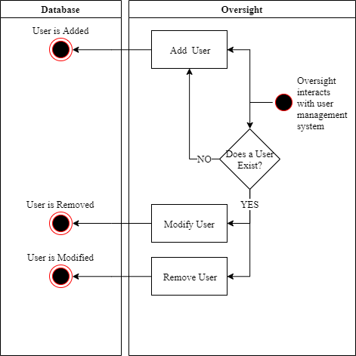

# Main/Basic Flow(s) of Events (Happy Path)

For each main flow (usually ONE flow) write the list of steps that occur – describe WHAT occurs not HOW to do it!

## User is added

* An Oversight team user interacts with the system
* Oversight team user adds a new user
* User is added in the Database

## User is removed

* An Oversight team user interacts with the system
* A user exists
* Oversight team user Removes a user.
* User is Removed in the Database

## User is Modified

* An Oversight team user interacts with the system
* A user exists
* Oversight team user Modifies a user.
* User is Modified in the Database

# Alternate/Exception Flow of Events

**7.1 User Is Not Modified/Removed (Because No User Exists)**

* An Oversight team user interacts with the system
* A user does not exist
* Oversight team user Adds a user.
* User is Added in the Database

# Assumptions/Business Rules including Non-Functional Requirements

Assume that users are already credentialed properly before being added to the company (their permissions to databases and the like) and that their credentials will be revoked in the event of their departure.

1. A STENER can contain no Questions

# Use Case Specification Review and Signoff

|  |  |  |  |
| --- | --- | --- | --- |
| Review and Signoff of the Use Case Specification | | | |
| Name | Project Team Role | Signature | Date |
| Ahmed, Zakariya | Senior Tech Lead/SPMP manager | Z.A. | 12/14/19 |
| Alhaidar, Muaz | Developer | M.A. | 12/14/19 |
| Longworth, Kevin | Developer | K.L. | 12/14/19 |
| Labut, Cameron | Developer | C.L. | 12/14/19 |
| Majzoub, Mostafa El | Developer | M.M | 12/14/19 |